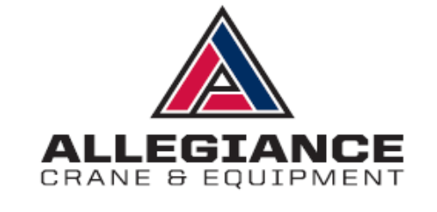

[Date]

[Company Name]  [Address Line 1]  [Address Line 2]  [Company Phone] | [Contact Name]  [Project Name]  [Project Address Line 1]  [Project Address Line 2]  [Email]
We are pleased to quote the following equipment for the above referenced project.
Equipment Rental Proposal
[80 Ton] Hydraulic Crane to [scope of work]
Standard Hourly Rental Rate with an 8-hour minimum (Monday-Friday 7AM-5 PM).. $000.00 Per Hour
Mobilization In…………………………………………………………......................... $000.00
Mobilization Out……………………………………………………………………….. $000.00
Overtime after 8 hours and Saturday work is standard hourly rate plus…………… $90.00 Per Hour
Sunday and holiday work is standard hourly rate plus………………………………. $180.00 Per Hour
Certified 3D lift plan if required………………………………………………………. $450.00
A 10% fuel surcharge will be applied to all equipment listed……………………………………………………

Additional Provisions……………………
This proposal includes one operator per crane, liability insurance and standard rigging. Rental rates are valid for 30 days and the equipment as quoted is subject to availability. Prices do not include prevailing wage requirements or involvement of specialized insurance programs. If project requires prevailing wage or specialized insurance programs, customer must contact Allegiance Crane for revised pricing.

The lessee shall provide the following…………………
Level and stable compacted ground which shall adequately support the crane with outriggers extended.
Clear access to the site free of obstructions without delay for the erection and tear down. Any police, street permits or road barricades if required while the equipment is on the site. Any additional riggers, flagmen, special rigging or communication equipment if required.
If you should require any additional information, please contact me at 772-828-0386

Please sign and e-mail back in acceptance of this quote.

X__________________________ ______________________
Customer Signature Date

Josh Miller
Florida Sales
Email: jmiller@allegiancecrane.com
